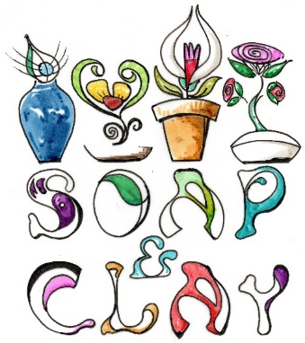
User Registration
It is not necessary to hold an account with us to make a purchase but it can provide a quicker experience. We will not share your personal information with any third parties – see our Privacy Policy for further details.
Our Products
All our products are handmade using naturally sourced and mostly botanical ingredients and are cut and packed by hand. Whilst we abide by legal guidelines for quantities and measures but items will vary by size and style. We think this is part of what is special about buying an artisan product and we hope you agree. Our ingredients are sourced by reputable UK-based suppliers and we maintain GMP (Good Manufacturing Practice) and operated by the UK Government guidelines for the sale of Cosmetic Products. We list our allergens for public awareness but cannot be held responsible for reactions that might occur due to an unknown condition. We manage our stock levels to the best of our ability but if you do make an order that we have run out of we cannot fulfil we will offer you a refund or will fulfil your order as soon as we can. (This could be between 1 -30 days).
Purchases and Payments
We accept all major bank and credit cards.
We cannot accept any orders until payment has been received.
We reserve the right to refuse any order placed through the Site. We may, in our sole discretion, limit or cancel quantities purchased per person, per household, or per order. These restrictions may include orders placed by or under the same customer account, the same payment method, and/or orders that use the same billing or shipping address. We reserve the right to limit or prohibit orders that, in our sole judgment, appear to be placed by dealers, resellers, or distributors.
Shipping
See our Shipping policy here.

Returns and Refunds
We pride ourselves on providing great quality products that are good for you and good for the planet. If for any reason you are unhappy then please let us know by emailing us at naturallyhandmade@soapandclay.co.uk and we will be very happy to assist you.

Unfortunately because of the organic nature of our soap and other bath products we cannot re-sell items and so can only offer an exchange rather than a refund for these products and only, as required by law, if they are faulty or not as described. Unfortunately we cannot refund or exchange if you change your mind once an item has been posted. If you do wish to receive a refund for a non-organic item then we are happy to do so upon receipt of the original item by return to us either at our Cambridge shop or by post. Receipt of purchase is required.

Please feel free to contact us if you have any further questions regarding this policy or if we can help in any other way.

Soap & Clay♥

